Assignment #3 – Business 100
Name:

Background information needed to answer Question #1:

Below are three different basketballs that each have unique features. Review those features and also the customer profile of your customers to determine which basketball you think will sell the most.

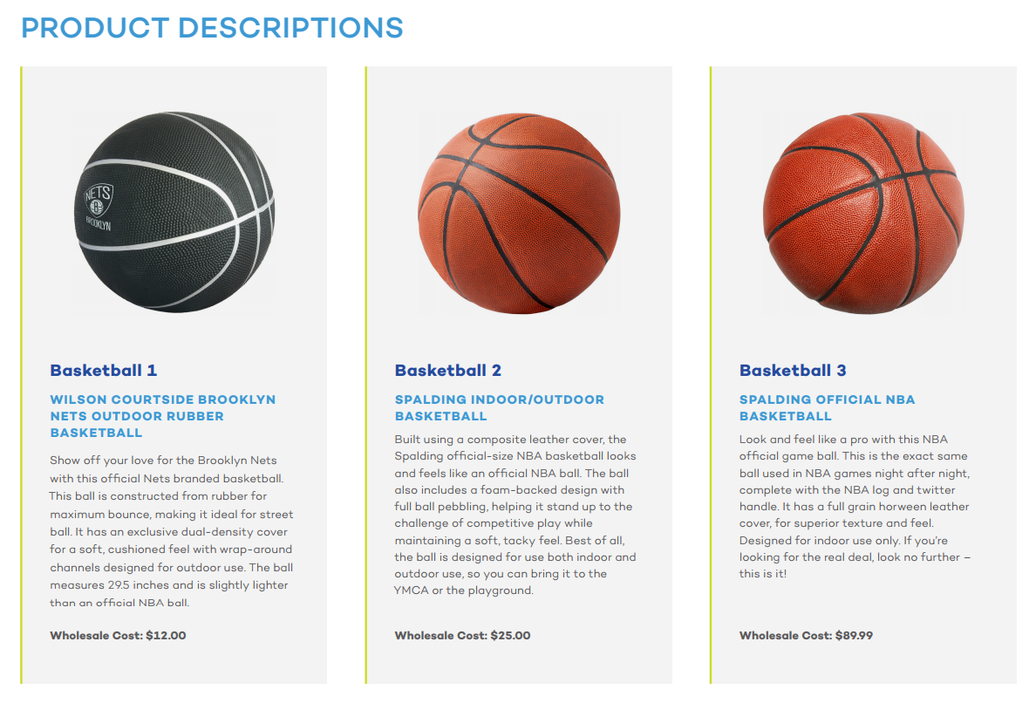

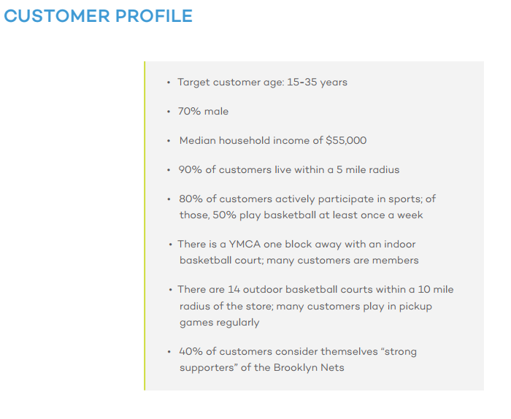
Question 1:
Based on the information provided in the customer profile, which basketball will sell the most?

- Basketball 1
- Basketball 2
- Basketball 3

What information from the customer profile indicates that your basketball choice will sell the most?

Background information needed to answer Question #2:

Review the survey results below that asked potential buyers about where they are most likely to purchase these products.

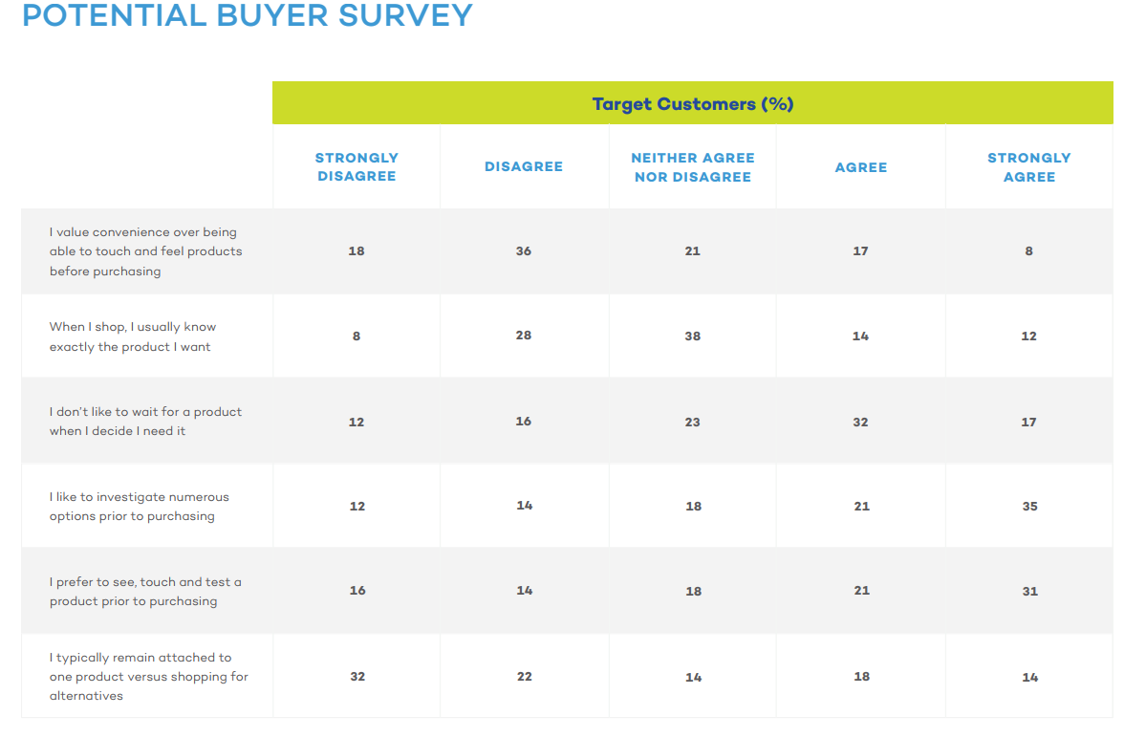
Question #2:

Where are potential buyers most likely to purchase a basketball?
- Traditional Store
- Online

Explain your answer using the survey data above:

Background information needed to answer Question #3:

Below are three recommended advertisements, including a special deal promotion, for the basketball that is expected to sell the best. Review and based on what you know about the customer profile that shops at this store location, determine which promotional activity will sell the most product at this particular store.

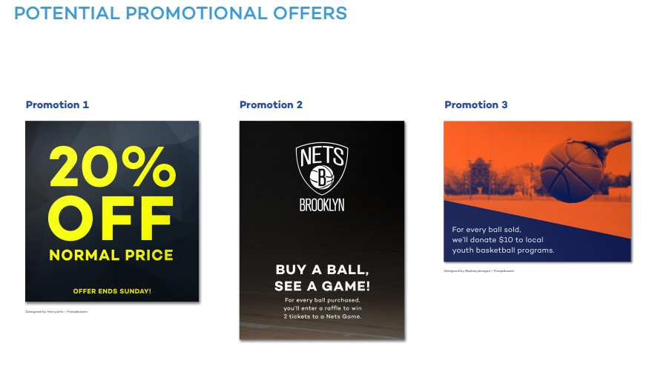
Question #3:

Which promotional activity will sell the most products?

- Promotion 1
- Promotion 2
- Promotion 3

Explain your rationale for your decision and include data from the customer profile:

Background information needed to answer Question #4:

Review the pricing options available for each of the three products below. Also review the wholesale cost to purchase the product as you review the best pricing strategy for all three products.
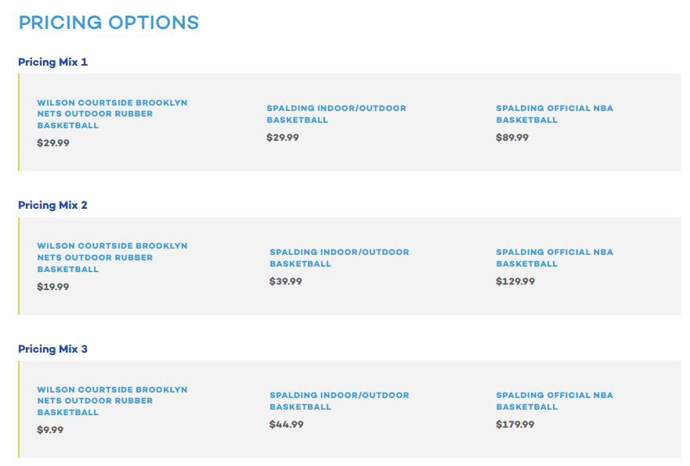
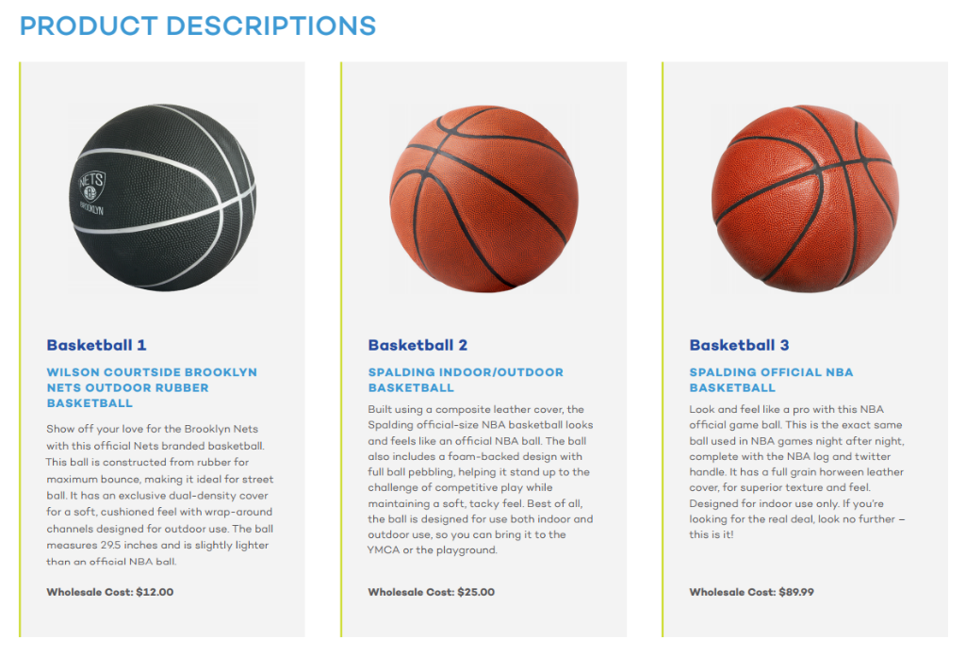
Question #4:

Based on your knowledge of Pricing Strategies, choose the Pricing Mix Option that has the best pricing mix for all three products.

- Pricing Mix 1
- Pricing Mix 2
- Pricing Mix 3

Please explain which Pricing Mix you selected and why?

Background information needed to answer Question #5:

The company that makes one of the basketballs is looking to rebrand the product. They have asked for your input on possible brands ideas. First, read the Brand Vision statement which summarizes the goal for the new brand. Then, look at the logo, name, and tagline recommendations.
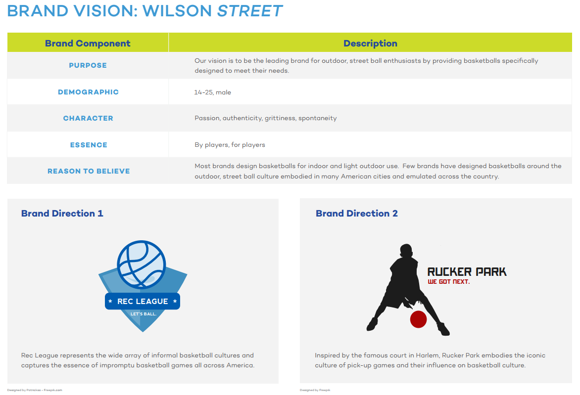
Question #5:

Which of the Brand Directions best meets the goals of the brand vision?
- Brand Direction 1
- Brand Direction 2

Why do you think your selected Brand Direction meets the goals the best?

Background information needed to answer Question #6:

A great sales pitch has 5 components: introduction, problem, solution, objections, call to action. Review the 5 components of a successful sales pitch as well as a few example sales pitches below.
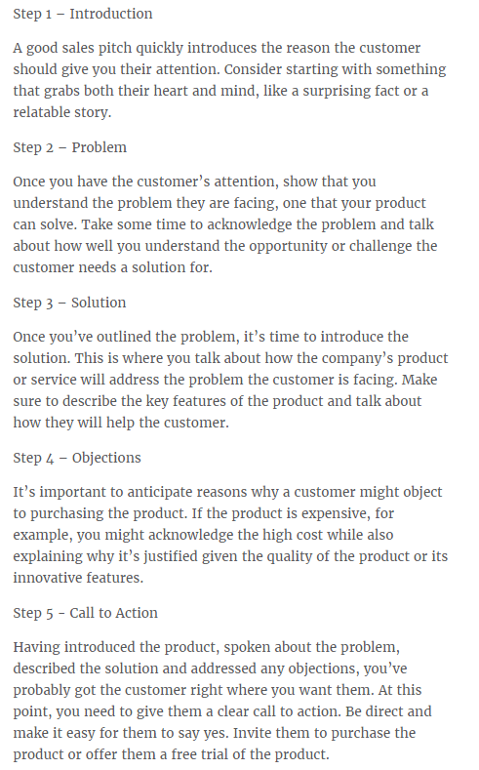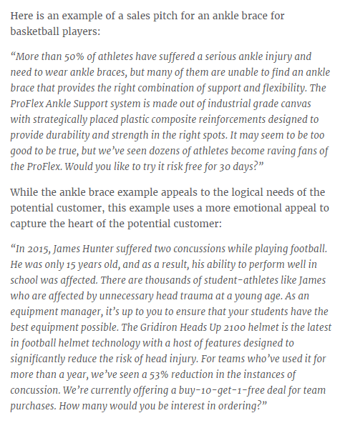
Question #6:

Write a sales pitch that you would use to try and convince someone to purchase this product.

Next step: submit your work
- Save this document to your desktop
  - Navigation: select file at the top, save as – select desktop, and select save
- Log into your class and select Assignment #3 on the left, scroll down and select “submit your work”, click browser my computer, find your file on the desktop, click open, then click submit.
- If you have any issues email me or call me.
I will provide you assignment feedback and you can then make any changes you would like and resubmit for grading.
Congrats on completing assignment #3!

